**NUS-ISS Masters of Technology - Knowledge Engineering**

Text Mining Report :   
Analysis of Workplace Accidents

**30 October 2017**

**Choong Yue Lin (A0150392L)**

**Ho Kok Loon (A0150144W)**

**Lee Tin Onn (A0150375J)**

**Lei Jun (A0150141B)**

**Vincent Leung (A0150347L)**

Table of Contents

**Analysis of Construction Fatality and Catastrophe Accidents** 3

Data 3

Accident types 4

Occupation 6

Body part injured 9

Activity prior to accident 10

Conclusion 12

References 13

**Analysis of Construction Fatality and Catastrophe Accidents**

The objective of this project is to investigate the nature of construction accidents, such that to provide insights to forecast safety performance as well as improve safety risk controls for companies in the construction industry.

# Data

We look at two datasets of construction accidents cases.

In addition to the case summaries, the Malaysia Accident dataset also contains the labelled 11 causes of accidents. Comparably, the OSHA (Occupational Safety and Health Administration) dataset is labelled with the main injury sustained.

The Malaysia dataset is smaller, consisting of 235 case summaries, while the OSHA dataset consists of 16323 cases. The Malaysia dataset are all case summaries of fatalities, while the OSHA dataset is a combination of fatal and catastrophe incidents, which include severe injuries such as amputation and in-patient hospitalisation [1].

To build a model to classify the cause of accident, the Malaysia dataset was split into 77:23, with 182 cases for training and 53 cases for testing. One mislabeled classification was replaced with the superset group’s label by changing ‘Others’ to ‘Other’. Three misclassified summary case was identified and re-labelled with the correct classification.

# Accident types

We look into the main types of accidents that result in fatality, using the Malaysia dataset for classification training, different models are trained with tf-idf (term frequency-inverse document frequency), and the best performing model, with 73.58% prediction rate, SVM based on case title, is then used to classify the OSHA dataset.

|  | Accuracy on Title text | Accuracy on Summary text |
| --- | --- | --- |
| Naive Bayes | 69.81% | 37.73% |
| Decision Tree | 64.15% | 52.83% |
| SVM | 71.70% | 56.60% |

After performing classification on OSHA data using the trained SVM model, the cause was determined. The fatal accidents in the OSHA dataset was filtered by matching words that indicates a fatality, and we obtained a subset of 6816 cases.

From the subset of cases, we are able to determine the most common accident type that result in fatality or catastrophe is ‘struck by moving objects’ accidents, accounting for 37.73% of the cases, followed by ‘falls’, which accounts for 3326 of the 16323 cases, consisting of 20.38% of the cases.

Similarly, the most common cause of fatalities is ‘struck by moving objects’, though with greater proportion, accounts for 2774 cases, 40.70% of the fatal accidents. The second most common accident type that result in fatality is ‘falls’, consisting 1430 cases, 21% of the fatal accidents.

The results closely match those found from the Malaysia Accident cases, which two most common accident types are also ‘falls’ and ‘struck by moving objects’.

|  |  |  |  |  |  |  |
| --- | --- | --- | --- | --- | --- | --- |
|  | OSHA | | OSHA Fatal | | Msia Accidents | |
| Cause | Count | Percentage | Count | Percentage | Count | Percentage |
| Caught in/between Objects | 1967 | 12.050481 | 830 | 12.177230 | 46 | 19.574468 |
| Collapse of object | 409 | 2.505667 | 206 | 3.022300 | 9 | 3.829787 |
| Drowning | 177 | 1.084359 | 154 | 2.259390 | 9 | 3.829787 |
| Electrocution | 1381 | 8.460455 | 409 | 6.000587 | 17 | 7.234043 |
| Exposure to Chemical Substances | 319 | 1.954298 | 106 | 1.555164 | 2 | 0.851064 |
| Exposure to extreme temperatures | 1499 | 9.183361 | 306 | 4.489437 | 3 | 1.276596 |
| Falls | 3326 | 20.376156 | 1430 | 20.980047 | 73 | 31.063830 |
| Fires and Explosion | 552 | 3.381731 | 348 | 5.105634 | 4 | 1.702128 |
| Other | 285 | 1.746003 | 146 | 2.142019 | 17 | 7.234043 |
| Struck By Moving Objects | 6159 | 37.732035 | 2774 | 40.698357 | 52 | 22.127660 |
| Suffocation | 249 | 1.525455 | 107 | 1.569836 | 3 | 1.276596 |

# Occupation

The occupation is not clearly stated in majority of the cases and it’s almost impossible to get the exact title from it. So a different approach had to made to get the occupation. To tackle this problem, a lookup library would have to be created by linking occupation towards keywords reside each of the cases. The identified list of occupation names was obtained based on heuristic knowledge. To enhance the selection of the name, word cloud was created to look at the most common words appear in the entire cases.

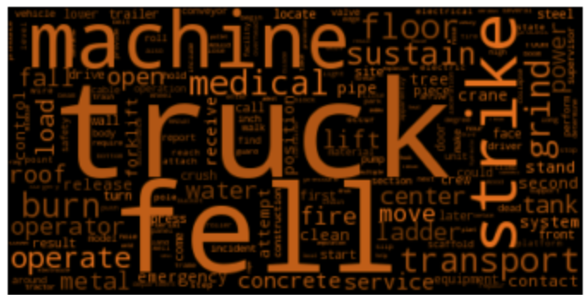

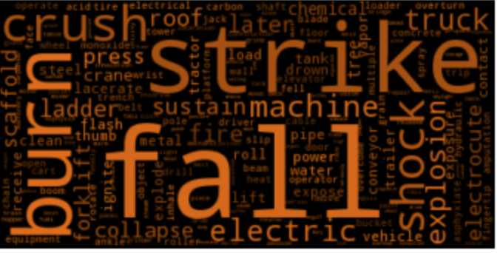

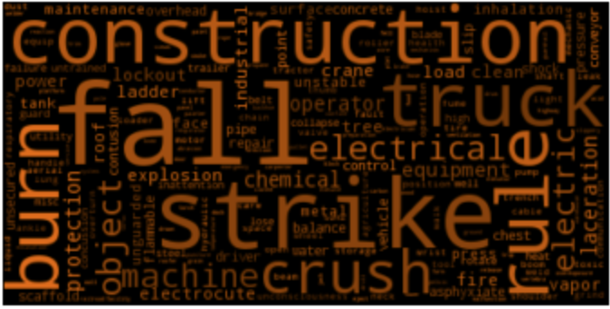

As can be seen, the word such as truck, fell, burn, construction, machine, transport etc commonly appear in the cases and we based on this to further zoom in the relevant occupations associated to these words.

A lookup table in the form of dictionary was created as showed below,

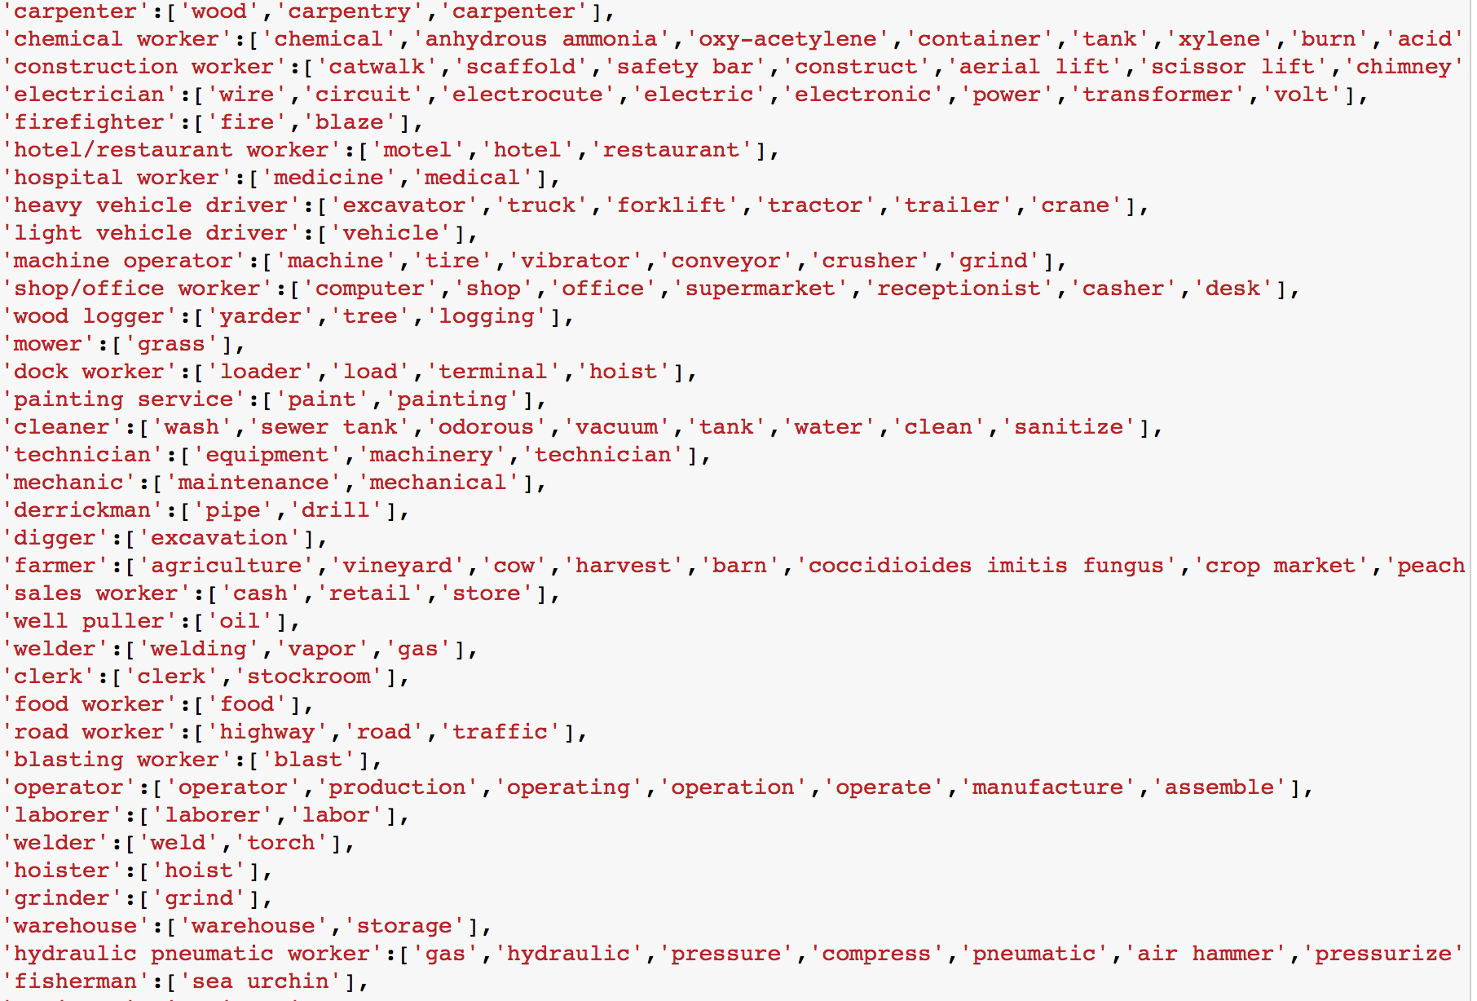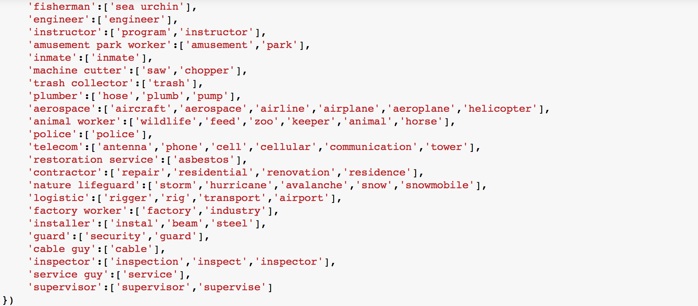

A total of 58 occupation titles were hand picked and this was the most time consuming effort for this section. Using this occupation dictionary, we went a head to screen thru it against the list of cases in the spreadsheet. As the keywords might repeat or appear across few occupations, we took the highest occurrence of the keyword to down select the occupation. We were able to assign occupation to most of the cases accept for 132 cases where either the content is not relevant or the description is to vague to warrant an occupation title for it.

Below is the distribution of occupation and frequency of occurrence segregated based on the causes of accident. The construction worker turnout to be the most frequent accident occupation.

| OSHA | | | Struck By Moving Objects | | |
| --- | --- | --- | --- | --- | --- |
| Occupation | Count | Percentage | Occupation | Count | Percentage |
| **construction worker** | 3636 | 22.275317 | **heavy vehicle driver** | 988 | 16.041565 |
| **heavy vehicle driver** | 1614 | 9.887888 | **construction worker** | 851 | 13.817178 |
| **chemical worker** | 1172 | 7.180053 | **machine operator** | 637 | 10.342588 |
| **machine operator** | 1141 | 6.990137 | **operator** | 463 | 7.517454 |
| **electrician** | 1074 | 6.579673 | **cleaner** | 266 | 4.318883 |
| **:** | : | : | **:** | : | : |

| Falls | | | Caught in/between Objects | | |
| --- | --- | --- | --- | --- | --- |
| Occupation | Count | Percentage | Occupation | Count | Percentage |
| **construction worker** | 1720 | 51.713770 | **construction worker** | 326 | 16.573462 |
| **heavy vehicle driver** | 148 | 4.449790 | **machine operator** | 302 | 15.353330 |
| **installer** | 140 | 4.209260 | **heavy vehicle driver** | 247 | 12.557194 |
| **cleaner** | 116 | 3.487673 | **operator** | 214 | 10.879512 |
| **carpenter** | 99 | 2.976548 | **cleaner** | 97 | 4.931368 |
| **:** | : | : | **:** | : | : |

# Body part injured

| OSHA | | | Struck By Moving Objects | | |
| --- | --- | --- | --- | --- | --- |
| Bodyparts | Count | Percentage | Bodyparts | Count | Percentage |
| **hand** | 3019 | 11.788824 | **hand** | 1388 | 13.769841 |
| **foot** | 2682 | 10.472881 | **finger** | 1201 | 11.914683 |
| **head** | 2250 | 8.785974 | **head** | 925 | 9.176587 |
| **finger** | 1936 | 7.559842 | **foot** | 796 | 7.896825 |
| **back** | 1596 | 6.232184 | **hand** | 1388 | 13.769841 |
| **:** | : | : | **:** | : | : |

Of 118 types of body parts and 25609 injuries, the most common body part injured is hand, comprising of 11.79% of injured body parts. Followed by foot, and head, accounting for 10.47% and 8.79% respectively.

| Falls | | | Caught in/between Objects | | |
| --- | --- | --- | --- | --- | --- |
| Bodyparts | Count | Percentage | Bodyparts | Count | Percentage |
| **foot** | 1044 | 18.943930 | **hand** | 569 | 16.705813 |
| **head** | 692 | 12.556705 | **finger** | 448 | 13.153259 |
| **leg** | 399 | 7.240065 | **foot** | 288 | 8.455666 |
| **back** | 338 | 6.133188 | **arm** | 250 | 7.339988 |
| **hand** | 232 | 4.209762 | **head** | 240 | 7.046389 |
| **:** | : | : | **:** | : | : |

The most common body parts that are injured are appendages such as hand and foot.

# Activity prior to accident

The activity prior to the accident is identified by identifying the verb in each summary, and checked against an activity list. Tools used in performing this extraction are as follows :

1. NLTK Regular Expression Parser to extract the phrases containing the verbs
2. NLTK lemmatizer to find the base word of the verbs
3. Simple word filters to further fine tune the accuracy of the activities extracted.

The most common activity prior the accident is the operating machinery. Followed by moving objects, standing in precarious positions and cleaning. 28260 distinct activities were extracted for OSHA dataset, whereas, only 138 activities could be extracted from the Malaysia dataset.

Challenges in extracting activities from the dataset:

1. Malaysia dataset only have <Summary> column which is a shorter description of the accident whereas Osha has a more detailed <Description> column which provides a more detailed description. Thus the activities extracted from Malaysia dataset is limited.
2. In some sentences, for example, the actually activity is "handling the work of maintaining", thus the actual activity is maintenance work but because the regular expression parser is designed to extract the verb activity resulted in "handling" being captured instead of "maintaining" and results in a less than accurate description of the activity extracted from the dataset. Further fine tuning were required to address this issue by only extracting the last verb which is “maintain”.

| Top 5 activities prior to accident | |
| --- | --- |
| Malaysia accidents | OSHA |
| Lifting | operating |
| installing | standing |
| moving | removing |
| carrying | moving |
| cutting | cutting |

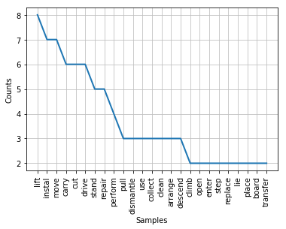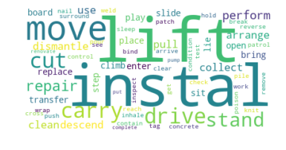

*Frequency distribution and word cloud for activity in Malaysia dataset*

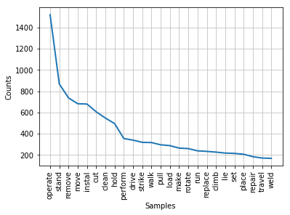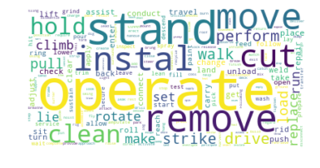

*Frequency distribution and word cloud for activity in Malaysia dataset*

| OSHA | | |
| --- | --- | --- |
| Struck By Moving Objects | Falls | Caught in/between Objects |
| operating | installing | operating |
| moving | standing | moving |
| cutting | removing | standing |
| standing | climbing | cleaning |
| removing | walking | rotating |

# Conclusion

The most common accident in workplace accidents is ‘struck by moving objects’. And the most risky occupation that results in fatal or catastrophe accidents is construction worker. And the most common part of the human body that is injured is hands. And the most common activity engaged in prior to such accidents is operating machinery.

**Learnings**

Below are the learnings from the assignment:

1. Through the assignment, we were able to apply text mining knowledge in a typical text mining problem end to end, from the data (or corpus) pre-processing to feature extraction to modelling.
2. At the same time, there was good appreciation of the challenges in a text mining problem such as dealing with
3. Bag of words method is simply not enough to provide solution to a problem. A combination of Natural Language Processing (NLP) in combination with bag of words as well as further customization and fine tuning using domain knowledge is required to improve the results accuracy.

**Future Improvements**

Given more time the following could be applied to further improve the results accuracy:

1. Obtain more datasets from accident records from other countries so that we can have a bigger dataset to train
2. Apply more domain knowledge to further improve performance. For example, a combination of keywords such as machinery, operate, install would tell us it’s an industrial related and drowning and suffocation is highly unlikely. For drowning, it is also unlikely there’s bodily injury to limbs etc. Time of the day and location the incident took place could also eliminate some causes. For example, if the incident took place outdoor, it is unlikely exposre to extreme temperatures etc.

# References

1. UNITED STATES DEPARTMENT OF LABOR. 2017. *Severe Injury Reports | Occupational Safety and Health Administration*. [ONLINE] Available at: <https://www.osha.gov/severeinjury/index.html>. [Accessed 22 October 2017].